# COMPUTER NETWORKS AND INTERNET OF THINGS

**TOPIC:**

TEMPERATURE AND HUMIDITY DETECTION SYSTEM

(DOCUMENTATION)

# TABLE OF CONTENTS

|  |  |
| --- | --- |
| **Title** | **Page no.** |
| Abstract | 3 |
| Scope | 4 |
| Functional requirements | 5 |
| Non-functional requirements | 6 |
| Description | 7 |
| Tools and technology used | 8 |
| Design and testing | 9 |
| Implementation | 11 |
| References | 12 |

**ABSTRACT**

Monitoring is an essential aspect of environmental changing conditions. It is basically employed to assess and mapping of biodiversity over vast regions, in alerting of any changes to the climate conditions, and identifying the zones to be

well protected. Therefore, it is inevitable to globally monitoring the earth for identifying and assessing climate changes. The prime motivation for the weather station is to track any changes in weather parameters.

At the present time, as it is obvious that both humidity and temperature constitute the main factors that should be considered in design of modern weather stations. The highly demanded weather station are characterized with high efficiency, compacted size, portable (in order to measure remote areas), and low power consuming. In contrary to the traditional bulky and high-power consuming

weather station. Hence, there is a need of temperature and humidity detection system.

# SCOPE

The scope of temperature and humidity detection system is quite broad and covers a range of applications that can be integrated anywhere. The main purpose of a temperature and humidity detection system is to track the present and future temperature records for the benefit of the society. It enhance the quality of life by providing convenience, comfort, and energy efficiency.

High precision and stable performance have always been the rigid indicators of temperature and humidity sensors.

So, the development priorities of temperature and humidity sensors in the future are: -

* Fault detection and prediction using machine intelligence.
* Remote sensing for target component analysis.
* Sensor intelligence for efficient circulation of resources.
* Current sensing technology can accurately sense physical or chemical quantities at a single point, but it is difficult to sense multi-dimensional states. For example, environmental measurement, whose characteristic parameters are widely distributed and have temporal and spatial correlations, are also a type of problem that needs to be solved urgently. Therefore, it is necessary to strengthen the research and development of multi-dimensional state sensing.

# Functional Requirements

* Energy efficiency: The system should be designed to maximize energy efficiency, such as by turning off devices when they are not in use or adjusting the temperature based on occupancy patterns.
* Real-time monitoring: The project should monitor the data in real-time to detect and Control the LED’s
* System maintenance: The system should be designed to minimize false alarms and require minimal maintenance.
* Alert Notification: The system should send alerts or notifications to the user if the temperature exceeds a predefined threshold value.
* Power Management: The system should have an efficient power management system to conserve energy and extend the battery life.

# Non-Functional requirements

* Reliability: The system should be highly reliable with a high degree of accuracy and minimal false positives.
* Usability: The system should be easy to use and understand for users with varying levels of technical expertise.
* Scalability: The system should be scalable, up or down depending on the size of the home and level of security required.
* Security: The system should be secured against hacking or other security breaches.
* Performance: The system should have high performance and be able to respond to intrusion attempts quickly and efficiently.
* Compatibility: The system should be compatible with a wide range of sensors and technologies to allow for easy integration.
* Maintenance: The system should require minimal maintenance and be easy to troubleshoot and repair in case of issues.

# DESCRIPTION

A temperature and humidity sensor using an Arduino is a simple project that can be done with minimal electronics and coding knowledge. The most commonly used temperature and humidity sensor is the DHT11 sensor. These sensors are relatively inexpensive, accurate, and easy to use.

Here are the materials you'll need:

* Arduino board (e.g. Arduino UNO)
* DHT11temperature and humidity sensor
* Breadboard
* Jumper wires

Here's how to connect the DHT11 sensor to the Arduino board:

1. Connect the VCC pin of the sensor to the 5V pin of the Arduino board.
2. Connect the GND pin of the sensor to the GND pin of the Arduino board.
3. Connect the data pin of the sensor to any digital pin of the Arduino board (e.g. pin

Once you have the hardware connected, we need to write a sketch (a program) that reads the temperature and humidity values from the sensor and displays them on the serial monitor of the Arduino IDE.

# TOOLS AND TECHNOLOGY USED

* + Arduino Uno R3
  + DHT – 11 Sensor
  + LEDs
  + Resistors
  + Connecting Wires
  + Breadboard

# DESIGN AND TESTING

 Connect the VCC and GND of the module to the 5V and GND pins of the Arduino. Then connect the DATA pin to the Arduino’s digital pin 2. We communicate with DHT11 through this pin.

In the starting, we have included all the necessary libraries and defined the sensor type as DHT11 and the sensor pin as digital pin 2. And then created an instance for the DHT library. Also created a variable to declare the minimum delay.

Testing phase is very important in such systems and its testing is done manually to check for any possible error.

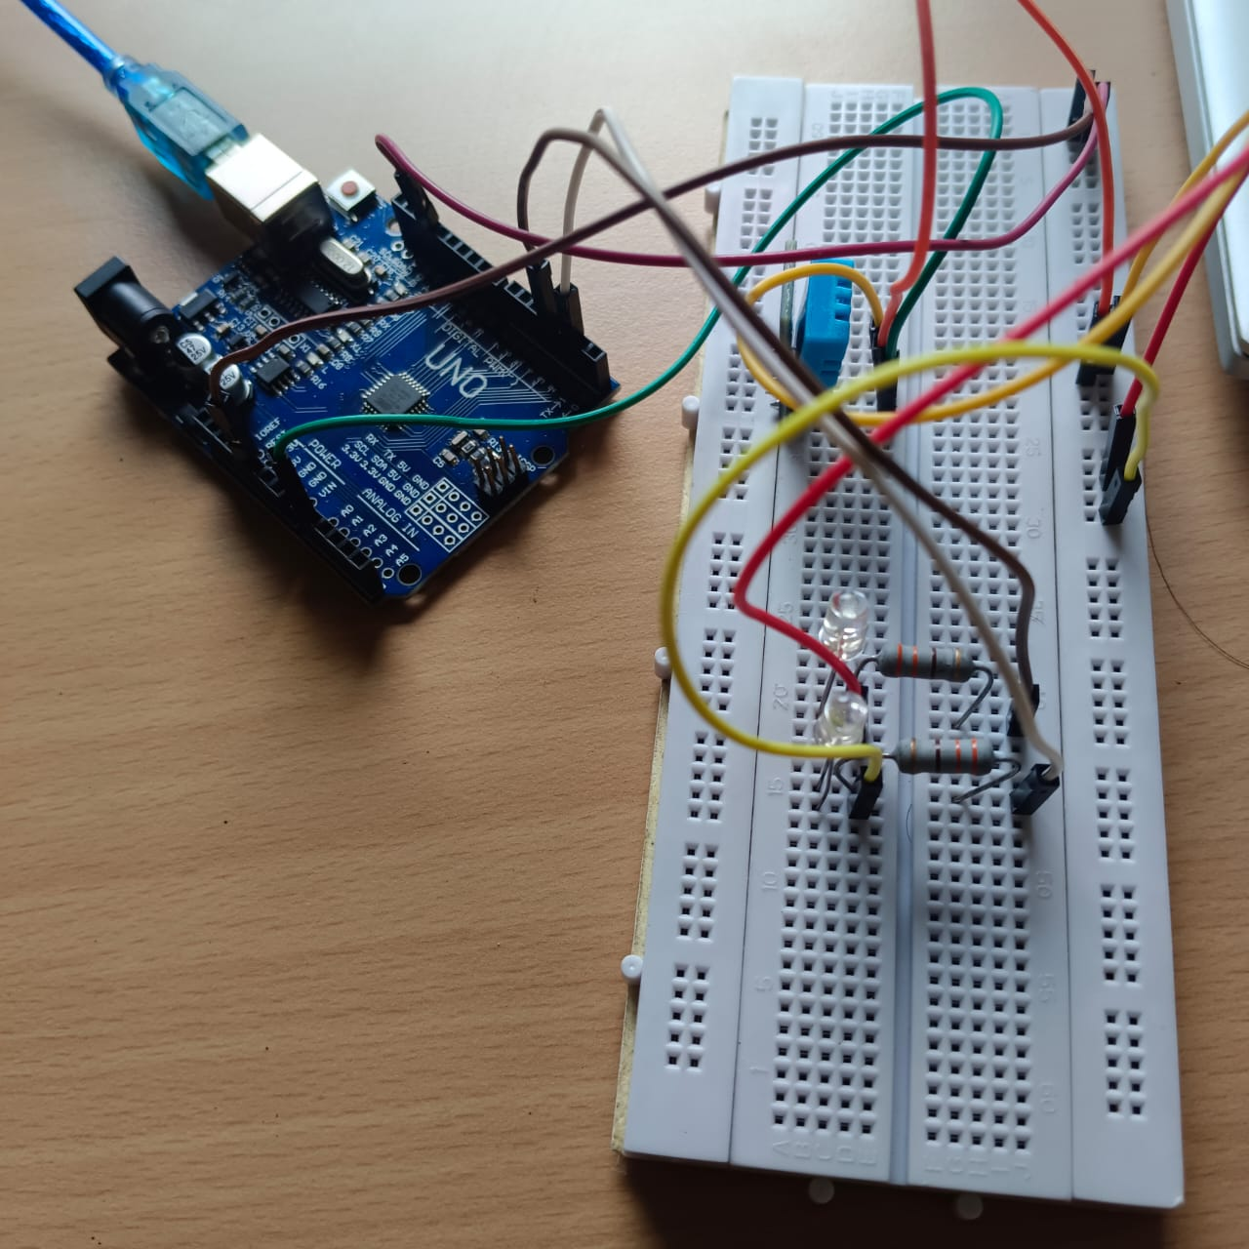

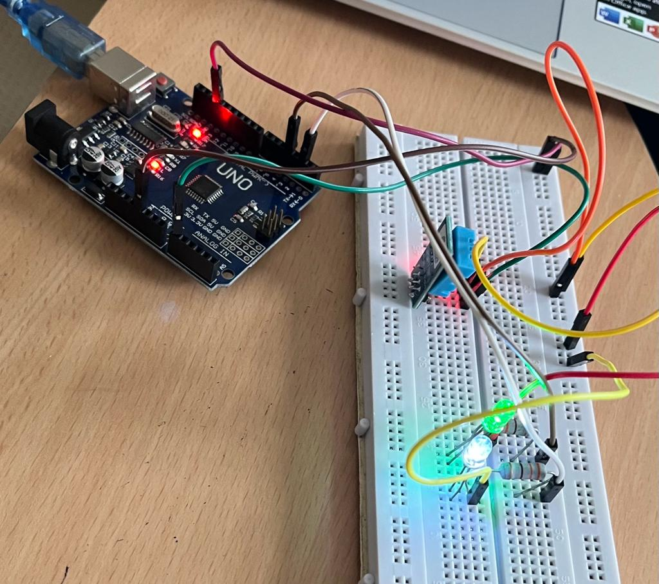

# IMPLEMENTATION

First, using a wire we have supplied 5V power supply from the Arduino 5V pin to the breadboard. And then, we have connected the Arduino GND pin to the ground of the breadboard.

Here, we have used DHT – 11 temperature and humidity sensor and connected it on the breadboard. The DHT – 11 sensors consist of 3 pins power supply (V), ground (GND), and D in order to provide the input to the Arduino.

We have used pin A0 as the input pin through which we will detect the temperature and humidity.

In order to show the output we have used two leds which will glow up on the basis of present temperature. The white led is connected with port 2 of Arduino and the green led is connected with the port 4 of Arduino. If the temperature is greater than 30 degree Celsius, then green led would glow. If the temperature is less than 30 degree Celsius and greater than 20 degree Celsius, then both green and white led would glow. If the temperature is less than 20 degree Celsius, then only white led would glow.

Overall, this project will be based on Arduino based microcontroller and the results will be visible both physically as well as on the serial monitor of the laptop screen.

# REFERENCES

* + https://circuitdigest.com/microcontroller-projects/interfacing-dht11-sensor-with-arduino “The Complete Guide to Home Automation" by Joshua Wright.
  + <https://www.scribd.com/document/510655668/Humidity-Temperature-Monitoring-System-by-Using-Arduino>
  + Create Your Own Arduino-based smart temperature and humidity detection system by Marco Schwartz and Alberto Ricci Bitti.